Weather APIs

🌤️ What Are Weather APIs?
# Source: AI Source: Provided by: [Data Path: Persons Table -> ID Column: 1, Name_En Column: Motasem Essam] -> From: [ChatGPT] on [1/19/2026]
Weather APIs are web services that provide real-time weather information, forecasts, historical data, and climate statistics. Apps, websites, and devices use these APIs to display weather conditions based on location (city, GPS, ZIP, IP, etc.).

✅ What Weather APIs Can Provide:
# Source: AI Source: Provided by: [Data Path: Persons Table -> ID Column: 1, Name_En Column: Motasem Essam] -> From: [ChatGPT] on [1/19/2026]
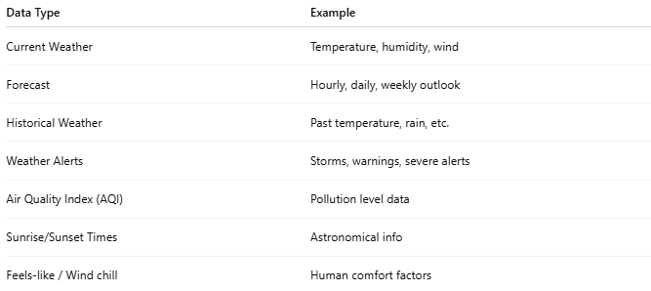

Data Type | Example
Current Weather | Temperature, humidity, wind
Forecast | Hourly, daily, weekly outlook
Historical Weather | Past temperature, rain, etc.
Weather Alerts | Storms, warnings, severe alerts
Air Quality Index (AQI) | Pollution level data
Sunrise/Sunset Times | Astronomical info
Feels-like / Wind chill | Human comfort factors

🧩 Popular Weather APIs
# Source: AI Source: Provided by: [Data Path: Persons Table -> ID Column: 1, Name_En Column: Motasem Essam] -> From: [ChatGPT] on [1/19/2026]
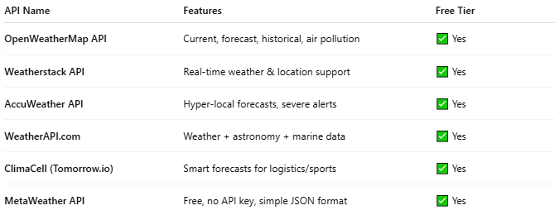

API Name | Features | Free Tier
OpenWeatherMap API | Current, forecast, historical, air pollution | ✅ Yes
Weatherstack API | Real-time weather & location support | ✅ Yes
AccuWeather API | Hyper-local forecasts, severe alerts | ✅ Yes
WeatherAPI.com | Weather + astronomy + marine data | ✅ Yes
ClimaCell (Tomorrow.io) | Smart forecasts for logistics/sports | ✅ Yes
MetaWeather API | Free, no API key, simple JSON format | ✅ Yes

📤 Example: OpenWeatherMap API
# Source: AI Source: Provided by: [Data Path: Persons Table -> ID Column: 1, Name_En Column: Motasem Essam] -> From: [ChatGPT] on [1/19/2026]
Request:
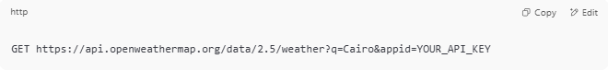
GET https://api.openweathermap.org/data/2.5/weather?q=Cairo&appid=YOUR_API_KEY

Response:
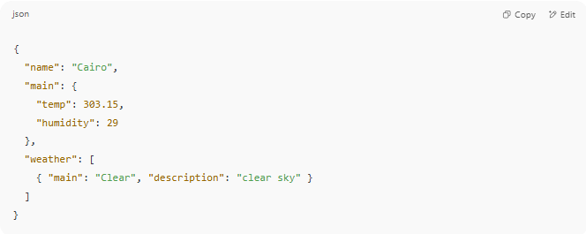
{
"name": "Cairo",
"main": {
"temp": 303.15,
"humidity": 29
},
"weather": [
{ "main": "Clear", "description": "clear sky" }
]
}

🌍 Location Parameters Supported by Most APIs
# Source: AI Source: Provided by: [Data Path: Persons Table -> ID Column: 1, Name_En Column: Motasem Essam] -> From: [ChatGPT] on [1/19/2026]
You can request weather data using:
- City name (e.g., Cairo, London)
- Latitude & Longitude
- ZIP code
- IP Address (for geolocation)
- City ID (in some services)

🧪 Use Cases
# Source: AI Source: Provided by: [Data Path: Persons Table -> ID Column: 1, Name_En Column: Motasem Essam] -> From: [ChatGPT] on [1/19/2026]
- Travel and tourism apps showing weather
- Smart home devices
- News and media sites
- Agricultural apps
- Health apps (allergy or air quality alerts)

